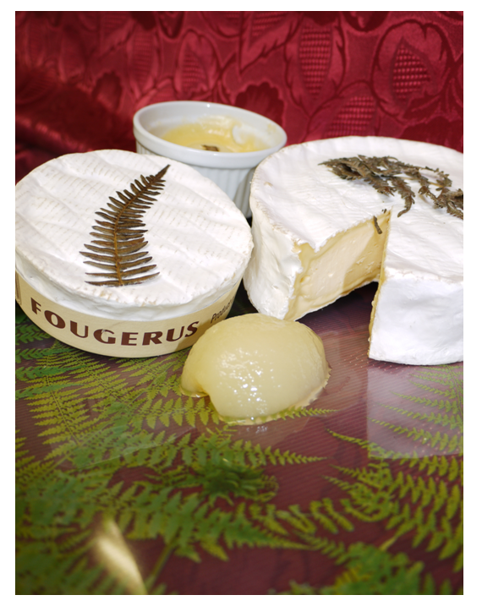
Cheese and desert
William Pear with Fougerus

Fill several porcelain bowls with William Pear, cover it with slices of Fougerus
(remove before rind and fern)
Put it 2 minutes in the micro-wave (750W).
Serve immediately

Pears Gratin with Fougerus

Roll a slice of Fougerus in bread-crumbs,
Fill in bowls on pear,
put onto grill until coloration
Serve immediately

Original and quick recipes!

The Fougerus is a raw milk cheese
made in the heart of the Brie by Rouzaire.

Un repas convivial, équilibré et original à partager entre amis.

